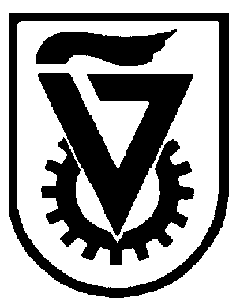 |  | הטכניון - מכון טכנולוגי לישראל  TECHNION - ISRAEL INSTITUTE OF TECHNOLOGY
הפקולטה להנדסה כימית
ע"ש וולפסון
The Wolfson Department of Chemical Engineering

Wolfson Department of Chemical Engineering Seminar

Monday, September 09th, 2024 at 14:00

Room 4

Solid solutions of tungsten in nickel-iron hydroxide catalyst for efficient hydrogen production

Lamea Abbas
MSc Seminar
Advisor: Prof. Yoed Tsur
Department of Chemical Engineering, Technion-Israel Institute for Technology

The search for green energy is growing in response to rising energy demands and environmental concerns. In this context, water splitting which dissociates water molecules into hydrogen and oxygen gases, plays a crucial role. This process requires two reactions: the Hydrogen Evolution Reaction (HER) at the cathode, and the more challenging Oxygen Evolution Reaction (OER) at the anode. Addressing the limitations of OER, our research focuses in enhancing the efficiency of nickel-iron hydroxide catalysts through tungsten doping. This approach aims to improve catalyst stability and performance by incorporating the tungsten dopant to modify conductivity and structural integrity.
Electrochemical Impedance Spectroscopy (EIS) is a key characterization method, extensively utilized for its effectiveness in analyzing reaction kinetics. By providing deep insights into the internal mechanisms and dynamics of electrochemical reactions, EIS provides a future scope to enhance material properties and refine reaction conditions. To analyze the collected data from the EIS technique, Impedance Spectroscopy Genetic Programming (ISGP) was used to produce the most accurately fitted model for the Distribution Function of Relaxation Times (DFRT). The DFRT modelling aids in evaluating the kinetics of the synthesized catalysts. This research enables us to understand the effect of the tungsten addition towards the electrocatalytic activity and stability of the modified catalysts.

