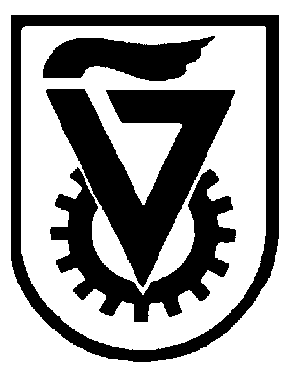 |  | הטכניון - מכון טכנולוגי לישראל  TECHNION - ISRAEL INSTITUTE OF TECHNOLOGY
הפקולטה להנדסה כימית
ע"ש וולפסון
The Wolfson Department of Chemical Engineering

Wolfson Department of Chemical Engineering Seminar

Monday, July 22rd, 2024 at 13:30

Room 4

Utilizing Vapor Phase Deposition Techniques to Enhance Mechanical Properties of Thin Films and Adhesion Joints

Shachar Keren
PhD Seminar
Advisor: Prof. Tamar Segal-Peretz¹, Prof. Noy Cohen²
- Department of Chemical Engineering, Technion-Israel Institute for Technology
- Department of Materials Science and Engineering, Technion-Israel Institute for Technology
Hybrid organic-inorganic materials are an exciting subclass of composites that have drawn increased interest in the last decades due to their synergic properties. Control over the mechanical properties of hybrid organic-inorganic nanomaterials is central to their implementation in a wide range of applications, including energy-absorbing materials, modified actuators, and protective coatings.
In recent years, vapor phase deposition techniques such as atomic layer deposition (ALD) and sequential infiltration synthesis (SIS) has emerged as promising techniques for fabricating hybrid materials with nanoscale precision. While SIS has shown potential in tuning the mechanical properties of polymers, the relationship between nanoscale structure, composition, and mechanical behavior is still an ongoing challenge.
In this research we explored and highlighted the potential of vapor phase deposition techniques to fabricate and modify hybrid materials with desired mechanical properties. Within this framework, we focused on two main aspects:
(1) Studying the mechanical behavior of hybrid thin films fabricated by sequential infiltration synthesis in water-rich environment. Our findings indicate that the mechanical properties of these films are significantly influenced by the aqueous environment.
(2) Enhancing adhesion strength of polymer-based joints via atomic layer deposition surface modifications. By depositing thin oxide layers on acrylonitrile butadiene styrene (ABS) surfaces, we tailored the surface morphology and chemical composition to improve adhesion. Our experiments showed that controlling the number of ALD cycles and the type of oxide layer can optimize the adhesion of 3D-printed ABS shear joints, offering a promising approach without compromising bulk properties.
These findings provide valuable insights into utilizing vapor phase deposition as a novel fabrication technique for designing and applying advanced materials.

Refreshments will be served at 13:15.

