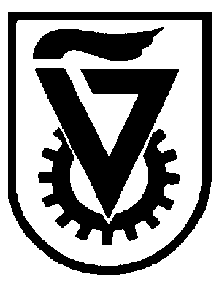 |  | הטכניון - מכון טכנולוגי לישראל  TECHNION - ISRAEL INSTITUTE OF TECHNOLOGY
הפקולטה להנדסה כימית
ע"ש וולפסון
The Wolfson Department of Chemical Engineering

Wolfson Department of Chemical Engineering Seminar

Monday, April 1st, 2024 at 13:30

Room 1

Electrochemical Oxygen Generation

Maisa Faour
MSc Seminar
Advisor: Prof. Dario Dekel
Department of Chemical Engineering, Technion-Israel Institute for Technology

Anion Exchange Membranes (AEMs) play a crucial role in fuel cells, electrolyzers and other electrochemical devices, by facilitating the selective transport of hydroxide anions, while blocking the transport of other undesired species. Here we report the utilization of AEMs in electrochemical oxygen separation. This technology represents a cutting-edge approach for producing enriched oxygen from gas mixtures like air, by leveraging a small voltage input. High-purity oxygen was successfully extracted from air, using a first-of-its-kind AEM-based electrochemical device, operating at low temperatures without liquid electrolytes or sweep gases. This device is a hybrid of fuel cells and electrolyzers, producing green oxygen of over 90% purity. It has a wide range of applications such as medical oxygen therapy, metal production, and various industrial processes, while reducing operational complexity and environmental impact.

Refreshments will be served at 13:15.

