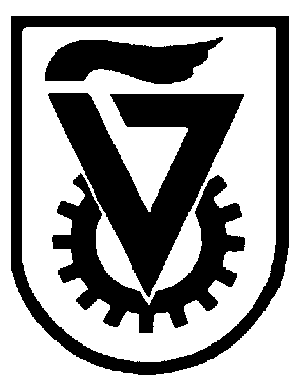 |  | הטכניון - מכון טכנולוגי לישראל  TECHNION - ISRAEL INSTITUTE OF TECHNOLOGY
הפקולטה להנדסה כימית
ע"ש וולפסון
The Wolfson Department of Chemical Engineering

Wolfson Department of Chemical Engineering Seminar

Monday, March 11th, 2024 at 14:00

Zoom: https://technion.zoom.us/j/96298325147

Structurally engineered PI-based Carbon membranes for CO₂ separation

Jiali Tang
MSc Seminar
Advisors: Prof. Xuezhong He and prof. Freger Viatcheslav
Department of Chemical Engineering, Technion-Israel Institute for Technology

Abstract: Carbon molecular sieve (CMS) membranes are appealing for energy-efficient gas separations on a wide scale due to their precise molecule discrimination and easy scalability. Herein, flat-sheet structurally engineered CMS membranes derived from five brand-new tailor-made 6FDA based polyimides with kinked structure are presented. The sub-nanopores in the CMS membrane were tailored by the structural engineering of precursor and regulating the pyrolysis process. A comprehensive “structure-to-performance” relationship was elaborated based on some characteristic and permeation testing.
The fresh 6FDA-TPEQ CMSMs-600 ℃ combining two powerful individual features (6F and kinked structures) in the backbone of polyimide precursors showed an exceptional CO₂ separation performance of 42064 barrer with CO₂/N₂ and CO₂/CH₄ selectivity of 30.1 and 24.3, respectively, surpassing the 2008 and 2019 Robeson upper bound. Moreover, a comprehensive study regarding the effect of pyrolysis conditions (pretreatment/final temperature and soaking time), operating parameters (e.g., pressure, temperature, flow rate, etc.) and aging properties was conducted to identify the optimal preparation and operating condition and evaluate the membrane stability. The developed carbon membranes show great potential for industrial CO₂ capture.

