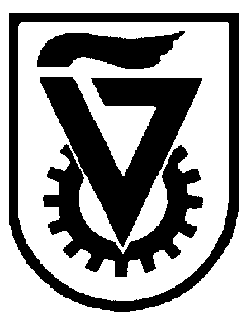 |  | הטכניון - מכון טכנולוגי לישראל  TECHNION - ISRAEL INSTITUTE OF TECHNOLOGY
הפקולטה להנדסה כימית
ע"ש וולפסון
The Wolfson Department of Chemical Engineering

Wolfson Department of Chemical Engineering Seminar

Wednesday, March 16th, 2022 at 13:30

# via Zoom: https://technion.zoom.us/j/97577956516

Controlling Metal Support Interactions in Hierarchical Catalysts for Promoting Methane Dry Reforming

Manar Halabi
Mid PhD Seminar
Advisor: Assoc. Prof. Oz Gazit
Department of Chemical Engineering, Technion-Israel Institute for Technology

Dry (CO₂) reforming of methane (DRM) is a well-studied reaction that is of both scientific and industrial importance. It has gained much attention in recent years for its ability to convert two potent greenhouse gasses, CH₄ and CO₂, into syngas. The synthesis gas subsequently can be used to produce a wide range of products. The major issue for the industrial operation of DRM is the operation cost with respect to the products price. This can be overcome by using transition-metal based catalysts such as nickel (Ni). However, Ni based catalysts suffer from strong deactivation. Hence, the main goal of this research is to develop improved catalysts, stable under the harsh conditions of DRM reaction.
Recently, it was shown that a Ni catalyst supported on a hierarchical support, composed of a thin mixed metal oxide (MO) supported on a secondary underlying metal oxide, has great potential for the DRM promotion. However, the nature of interactions between the Ni and the hierarchical support and how they affect DRM catalysis is still not fully understood. Better understanding regarding the MSI effect on catalytic performance will improve catalyst’s properties, which in-turn will induce DRM promotion.
In order to improve the interaction between the MO layer and the ZrO₂ support I developed a new coating methodology for making the hierarchical catalysts Ni/MO/ZrO₂. The methodology was evaluated for particulate and nanofibers (NFs) based ZrO_{2.} Their catalytic performance was tested in DRM reaction for 9 h at 800 °C. To gain structure-function-relationship the catalysts were characterized by SEM, TEM, XRD, UV-vis, TPR and TPD. It was found that catalysts with different Mg⁺²/Al⁺³ ratio, in the intermediate MO layer, have different activity and selectivity in DRM reaction. The ratios 3.5:1 and 2.5:1 had the highest CH₄ conversion and selectivity toward H₂. The activity of the catalysts composed of NFs was found to be affected by the support calcination temperature. We also show that the doping with yttria provides a dramatic increase in catalytic performance.

