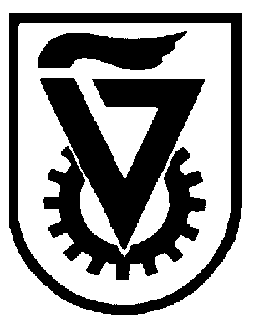 |  | הטכניון - מכון טכנולוגי לישראל  TECHNION - ISRAEL INSTITUTE OF TECHNOLOGY
הפקולטה להנדסה כימית
ע"ש וולפסון
The Wolfson Department of Chemical Engineering

Wolfson Department of Chemical Engineering Seminar

Thursday, November 4rd, 2021 at 17:30

Online seminar via Zoom
https://technion.zoom.us/j/96691523373

Local delivery of liposomal formulations for the treatment of cancer and inflammatory disorders

Mohammed Alyan
PhD Seminar
Advisor: Prof. Avi Schroeder
Department of Chemical Engineering, Technion-Israel Institute for Technology

Abstract
Acute Respiratory Distress Syndrome (ARDS), associated with Covid-19 infections, is characterized by diffuse lung damage, inflammation and alveolar collapse that impairs gas exchange, leading to hypoxemia and patient’ mortality rates above 40%. We assessed the ability of 100-nm liposomes tailored for pulmonary delivery to treat ARDS. The liposomal lipid composition was optimized to mimic the lung surfactant composition, into which two drugs methylprednisolone (MPS), a steroid, and N-acetyl cysteine (NAC), a mucolytic agent, were loaded. In vitro, treating lipopolysaccharide (LPS)-stimulated RAW 264.7 macrophages with the liposomes decreased TNFα and nitric oxide (NO) and secretion. In vivo, we assessed the nanoparticle accumulation and therapeutic efficacy either by intravenous (IV), endotracheal (ET) or both IV and ET administrations.
We further sought to take advantage of this liposome technology to treat oral cancers. For this, we developed a dry, dissolvable tablet based on dry doxorubicin-loaded liposomes mixed within an alginate powder. The tablets adhered to the mucosal tissue and released an anti-cancer drug by locally, resulting in the reduction of tumor size in vivo and density decreasing dysplasia and squamous cell carcinoma together with tumor area shrinkage.

