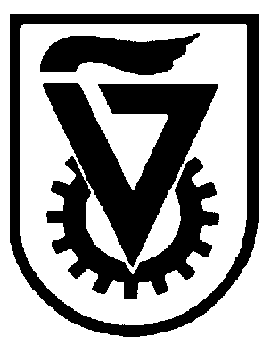 |  | הטכניון - מכון טכנולוגי לישראל  TECHNION - ISRAEL INSTITUTE OF TECHNOLOGY
הפקולטה להנדסה כימית
ע"ש וולפסון
The Wolfson Department of Chemical Engineering

Wolfson Department of Chemical Engineering Seminar

Wolfson Department of Chemical Engineering, Lecture Hall No. 6
Wednesday, October 6st, 2021 at 13:30

A few lessons that colloidal nanoparticles can teach us about dynamical chemical processes

Assaf Ben-Moshe

Department of Molecular Chemistry and Materials Science, Weizmann Institute of Science.

The fact that many chemical processes do not reach equilibrium, is quite obvious and not very surprising. Yet, this often complicates our attempts to understand and engineer their outcomes. Specifically, in the case of inorganic colloids, understanding crystal growth trajectories, and studying the transport of micro- and nano-scale particles in fluids, are two important topics relevant for current and future industrial applications, which are often governed by kinetic considerations.
Despite some complications that exist when trying to make analogies between the behavior of bulk and nano-scale crystals, the latter offer many advantages when trying to address some key questions about dynamical chemical processes and kinetic effects. In my talk I will present two different cases where advanced electron microscopy techniques, combined with the beneficial properties of nanocrystals enable us to shed light on such questions.
The first story, that deals with kinetic aspects of crystallization, dates all the way back to the 19th century and the seminal work by Louis Pasteur on crystals that exhibit chiral macroscopic shapes when made out of chiral building blocks. Using a nano-scale model system, we are able to show that the reason why chiral building blocks lead to formation of chiral shapes, in crystals, might not be as trivial as expected. In fact, our results suggest that there is no direct relationship between the chirality of the building blocks and a crystal’s tendency to form a chiral shape. This suggests that chiral shapes can be engineered in a much larger variety of materials than previously expected. This can also have important implications to the pharmaceutical industry, where control over chiral crystallization and separation is key.
In the second part of the talk, I will present our attempts, using liquid phase electron microscopy, to understand the basic rules that govern the transport of nano-particles in liquids. This is meant to pave the way to ultimately use them as building blocks for non-equilibrium active matter. More generally, this technique is expected to be most informative for studies of transport phenomena at extremely low Reynolds numbers.

Refreshments will be served at 13:15

