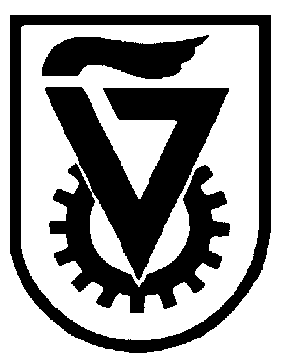 |  | הטכניון - מכון טכנולוגי לישראל  TECHNION - ISRAEL INSTITUTE OF TECHNOLOGY
הפקולטה להנדסה כימית
ע"ש וולפסון
The Wolfson Department of Chemical Engineering

Wolfson Department of Chemical Engineering Seminar

Monday, August 23th, 2021 at 14:00

Hybrid seminar- lecture hall #6 & Zoom
https://technion.zoom.us/j/94422290550

Modeling aneurysm rupture

Assoc. Prof. Konstantin Volokh
Department of Civil & Environmental Engineering, Technion – Israel Institute of Technology, Haifa, Israel

Aneurysms are abnormal dilatations of vessels in the vascular system, and they exist in two major forms: fusiform and saccular. Fusiform aneurysms are found in the human abdominal aorta. Saccular aneurysms are found in cerebral blood vessels. Growth and rupture of aneurysms are driven by micro-structural alterations of the vessel yet precise mechanisms underlying the process remain to be uncovered.
In the present work, we examine a scenario when the aneurysm evolution is dominated by turnover of collagen fibers. In the latter case, it is natural to hypothesize that rupture of individual fibers (or their bonds) causes the overall aneurysm rupture. We examine this hypothesis in computer simulations of growing aneurysms in which constitutive equations describe both collagen evolution and failure.
We find in a qualitative agreement with clinical observations that some aneurysms will rupture while others will not. According to the obtained numerical results, rupture occurs very quickly if it occurs at all. This qualitative conclusion has experimental support: cerebral aneurysms tend to rupture after a short period of intensive growth and those that survive are much less prone to rupture for a long period.
In addition, we examine the effects of cavitation and calcification on the decrease of the aneurysm strength. We show that the unstable growth of cavities might start when the critical stress is considerably less than the aneurysm strength. We also find that calcification can decrease the aneurysm strength significantly.

Refernces

Balakhovsky K, Jabareen M, Volokh KY (2014) Modeling rupture of growing aneurysms. J Biomech 47:653-658
Volokh KY (2015) Cavitation instability as a trigger of aneurysm rupture. Biomech Model Mechanobiology 14:1071-1079
Volokh KY, Aboudi J (2016) Aneurysm strength can decrease under calcification. J Mech Behav Biomed Mater 57:164-174

