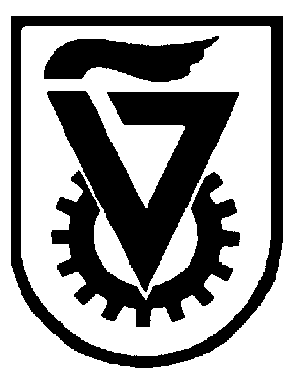 |  | הטכניון - מכון טכנולוגי לישראל  TECHNION - ISRAEL INSTITUTE OF TECHNOLOGY
הפקולטה להנדסה כימית
ע"ש וולפסון
The Wolfson Department of Chemical Engineering

Wolfson Department of Chemical Engineering Seminar
Wednesday, May 19th, 2021 at 13:30
Lecture Hall No. 6 (under Green Pass regulations)

The Enigmas of Surfaces

Prof. Emer. Avi Marmur
Department of Chemical Engineering, Technion

The properties of surfaces are crucial for many processes in a variety of areas in biology, industry, and daily life. Surprisingly, even though surface phenomena have been studied for more than 200 years by some of the greatest physicists, mathematicians, and engineers, there are still quite a few enigmas to be solved. This lecture presents some fundamental enigmas related to the surface tensions of liquids and solids that were either partially solved or yet unsolved.
If time frame permits, a different problem will be shortly described: the methodological development of (bulk) equations of state.

Refreshments will be served at 13:15

