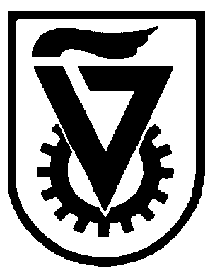 |  | הטכניון - מכון טכנולוגי לישראל  TECHNION - ISRAEL INSTITUTE OF TECHNOLOGY
הפקולטה להנדסה כימית
ע"ש וולפסון
The Wolfson Department of Chemical Engineering

Wolfson Department of Chemical Engineering Seminar

Monday - December 7, 2020 at 13:00 (Israel time)

Zoom Seminar ID - https://technion.zoom.us/j/94709017096

"Development of the high-performance mesh-free method to simulate
fluid flows"

Dr. Tibing Xu

Lecturer, Ocean Engineering Institute, Ningbo University - China

Fluid flows commonly occur in hydrodynamics, chemical engineering, and environmental engineering, etc. The flow characteristics need to be understood sufficiently to improve structure designs, enhance product performance, and optimize industrial processes. The mesh-free method provides a robust numerical candidate to help understand flow mechanics in various engineering areas. The method does not use any fixed meshes but discretizes the fluid with movable particles. It can conveniently handle fluid flows with severe deformation and large fragmentation. With devoting to the development of the mesh-free method for almost 8 years, Dr. Tibing Xu has successfully modeled various flows and he acquires two modules for the mesh-free method as hydrodynamic modeling module and granular flow module. Both of the modules are validated extensively by analytical solutions and experimental measurements, which would be further developed into Computational Fluid Dynamics (CFD) software in the future. This presentation introduces mesh-free module development and interesting applications in chemical engineering and environmental engineering.

